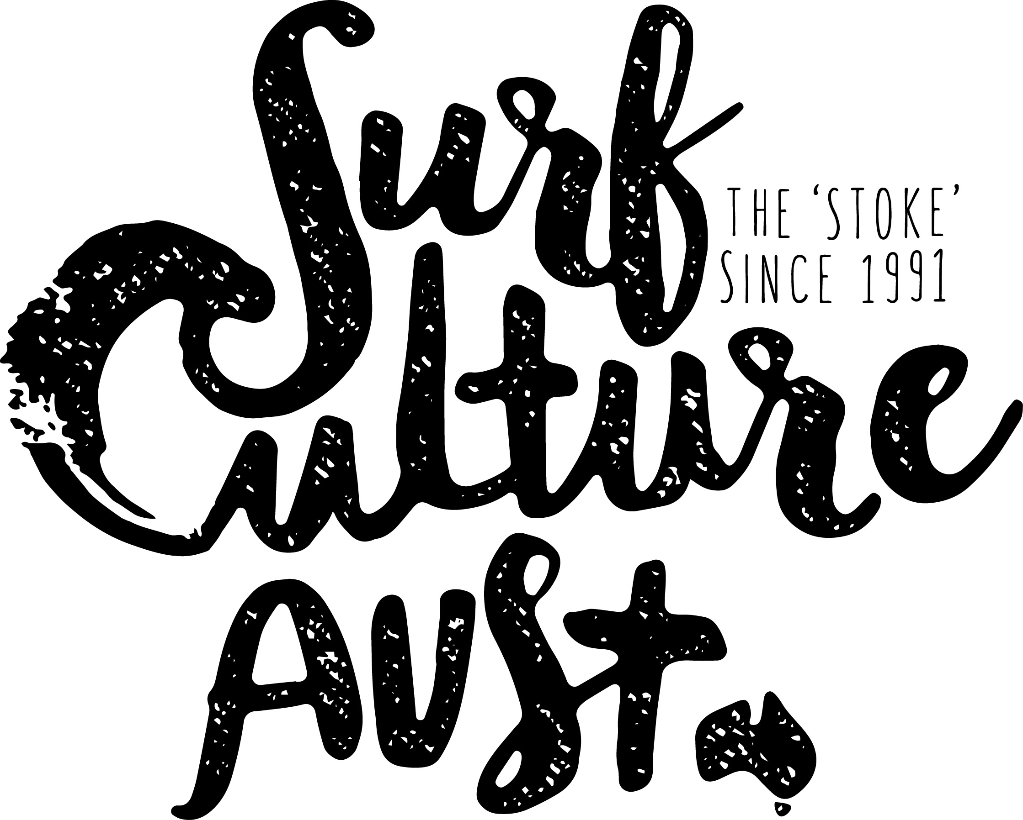
School or Private group registration and consent

School or Group Name
Contact Person |  | Mobile
Lesson Dates |  | Lesson Times
Year Level or Age |  | No of participants
Program Type (Camp, Outdoor Ed, Birthday Party) |  | Surfing Level (Beginner, Intermediate, Advanced)

In consideration of Organisers accepting my application to participate in the Program below, I acknowledge, understand and agree that:
- "Organisers" for the purposes of this declaration means the Surf Culture Australia surf school and includes, where the context so permits, Surfing Australia Inc (“SA”), SA affiliated state surfing associations and their respective directors, officers, members, servants or agents.

- Warning: Participating in the Program can be inherently dangerous. I understand the nature and requirements of the Program and acknowledge that serious accidents can and often do happen which may result in me being seriously injured or even killed. I have voluntarily read and understood this warning and accept and assume the inherent risks in participating in the Program.

- Swimming Ability and Physical Fitness: I must not participate in the Program if I do not have basic swimming ability or I have any injury, disability, medical or health condition that may increase the risk of me becoming injured unless I have told Surf Culture Australia about it and they have authorised me to participate. I declare that I am medically and physically fit and able to participate in the Program and I will immediately notify Surf Culture Australia of any change to my fitness and ability to participate. I understand and accept that Surf Culture Australia and SA will continue to rely on this declaration as evidence of my fitness and ability to participate.

- Instructions: I will at all times comply with the instructions and safety procedures of Surf Culture Australia.

- Medical Treatment: If required, Surf Culture Australia will arrange medical or hospital treatment (including ambulance transportation) for me. I authorise such actions being taken and agree to meet all costs associated with such action.

- Restricted Liability: Please refer to Form 1 found on the following page.

- Privacy: I understand that the information provided by me in this form is necessary for the operation of the Program. I acknowledge and agree that the information will only be used for the objects of Surf Culture Australia and to provide me with information pertaining to the Program and Surf Culture Australia activities. I understand that I will be able to access my information through Surf Culture Australia upon request. If the information is not provided, I might not be permitted to participate in the Program.

Teacher/Organiser Signature ____________________________________________________

Form 1—Recreational services—Exclusion, restriction or modification of rights under the Australian Consumer Law (SA) Your rights:
Under sections 60 and 61 of the Australian Consumer Law (SA), if a person in trade or commerce supplies you with services (including recreational services1), there is –
• a statutory guarantee that those services will be rendered with due care and skill; and
• a statutory guarantee that those services, and any product resulting from those services, will be reasonably fit for the purpose for which the services are being acquired (as long as that purpose is made known to the supplier); and a statutory guarantee that those services, and any product resulting from those services, will be of such a nature, and quality, state or condition, that they might reasonably be expected to achieve the result that the consumer wishes to achieve (as long as that wish is made known to the supplier or a person with whom negotiations have been conducted in relation to the acquisition of the services).
Excluding, restricting or modifying your rights:
Under section 42 of the Fair-Trading Act 1987, the supplier of recreational services is entitled to ask you to agree to exclude, restrict or modify his or her liability for any personal injury suffered by you or another person for whom or on whose behalf you are acquiring the services (a third-party consumer).
If you sign this form, you will be agreeing to exclude, restrict or modify the supplier's liability with the result that compensation may not be payable if you or the third-party consumer suffer personal injury2.
Important
You do not have to agree to exclude, restrict or modify your rights by signing this form.
The supplier may refuse to provide you with the services if you do not agree to exclude, restrict or modify your rights by signing this form.
Even if you sign this form, you may still have further legal rights against the supplier.
A child under the age of 18 cannot legally agree to exclude, restrict or modify his or her rights.
A parent or guardian of a child who acquires recreational services for the child cannot legally agree to exclude, restrict or modify the child's rights.
Agreement to exclude, restrict or modify your rights:
I agree that the liability of Surf Culture Australia for any personal injury that may result from the supply of the recreational services that may be suffered by me (or a person for whom or on whose behalf I am acquiring the services) (Liability) is—
(b) restricted as set out below:
Liability is excluded save where personal injury, loss or damage is caused or contributed to by the negligence, breach of contract, breach of a statutory duty or other duty by the supplier of recreational services including its servants, agents and contractors.
Signature: ___________________________________________________
Date: ___________________________________________________
Signature of witness: __________________________________________________
Name and address of witness: __________________________________________________

Definitions
1 Recreational services are services that consist of participation in—
• a sporting activity or similar leisure-time pursuit; or
• any other activity that involves a significant degree of physical exertion or risk and is undertaken for the purposes of recreation, enjoyment or leisure.
2 Personal injury is bodily injury and includes mental and nervous shock and death.
Further information: Further information about your rights can be found at cbs.sa.gov.au

Give an estimated size for wetsuit. Just a rough idea.
XS, S, M, L, XL, XXL for teen boys and men. 6, 8, 10, 12, 14, 16 for teen girls and women.
6, 8, 10, 12, 14, 16 for kids
jlkjlj

 | Student Name | Medical | Wetsuit Size | Comments
1
2
3
4
5
6
7
8
9
10
11
12
13
14
15
16
17
18
19
20
21
22
23
24
25
26
27
28
29
30

